**5. Hosting a static website on Amazon AWS.**

**HARDWARE REQUIREMENTS**: Core I5 Processor, 4 GB RAM, 40GB HDD

**SOFTWARE REQUIREMENTS**: Amazon AWS, S3, VS Code/Eclipse

**Description:**

**AWS (Amazon Web Services)**: a subsidiary of Amazon is a cloud computing platform which provides resources for computation such as EC2 instances, various database and storage facilities as well as networking and content delivery options.

**EC2 (Elastic Compute Cloud):** is a web service which provides computing power in the form of scalable server instances. Multiple EC2 instances are run on the same machine inside Amazon’s computing infrastructure. When an EC2 instance is initiated, a set amount of resources (OS, RAM, Disk Space etc., chosen at the time of initiation) are allotted to the user from the machine it runs on. This allows sharing of resources between multiple users.

**Amazon Simple Storage Service (Amazon S3):** is an object storage service that offers industry-leading scalability, data availability, security, and performance. This means customers of all sizes and industries can use it to store and protect any amount of data for a range of use cases, such as websites, mobile applications, backup and restore, archive, enterprise applications, IoT devices, and big data analytics. Amazon S3 provides easy-to-use management features so you can organize your data and configure finely-tuned access controls to meet your specific business, organizational, and compliance requirements. Amazon S3 is designed for 99.999999999% (11 9's) of durability, and stores data for millions of applications for companies all around the world.

**Steps To configure an S3 bucket for static website hosting:**

* Sign in to the AWS Management Console and open the Amazon S3 console at [https://console.aws.amazon.com/s3/](https://console.aws.amazon.com/s3/#_blank).

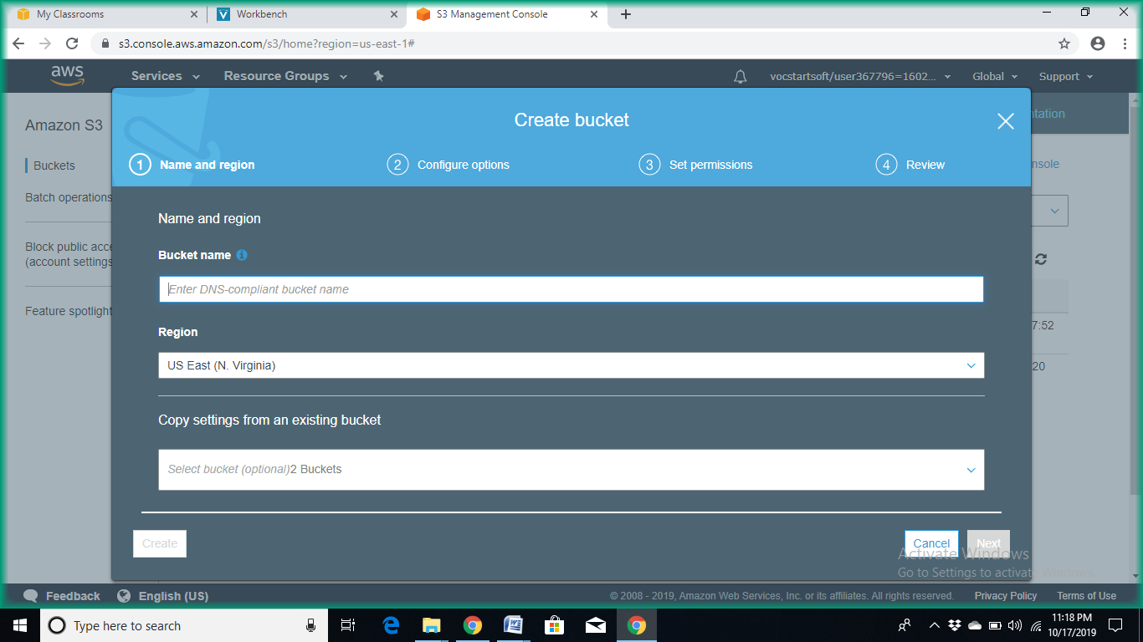

* Enter the bucket name and click on **Next**

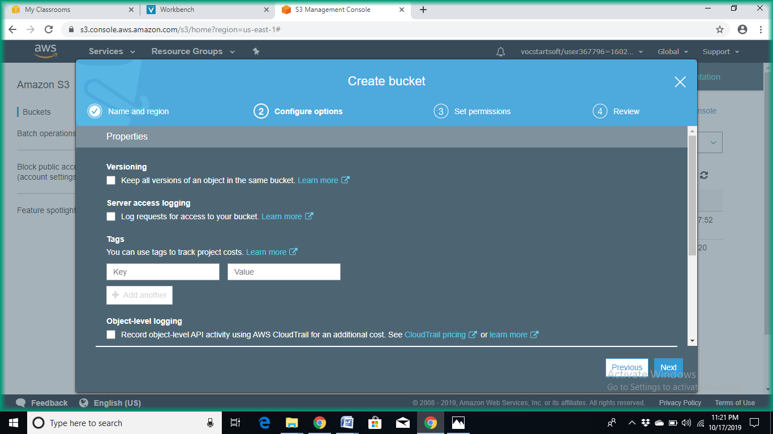

* Then click on **Next**

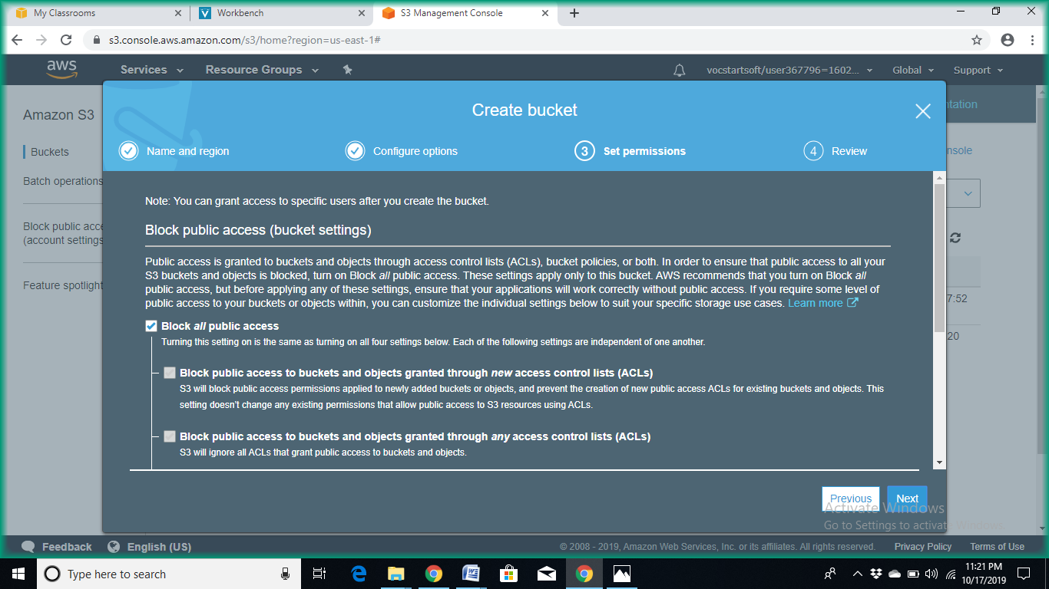

* Uncheck the checkbox “**Block all public access”**  and click on  **Next**

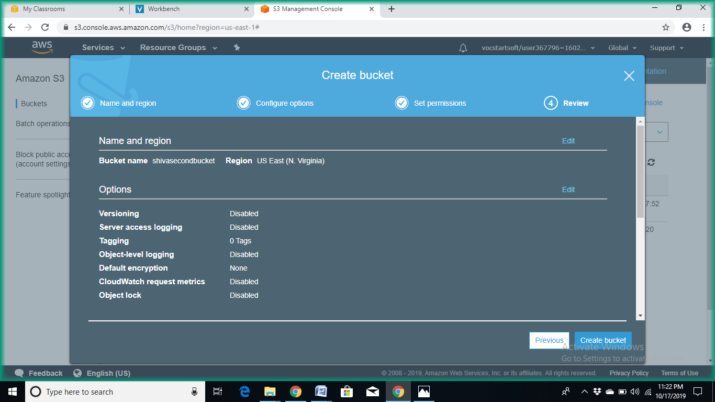

* Now click on **Create bucket**

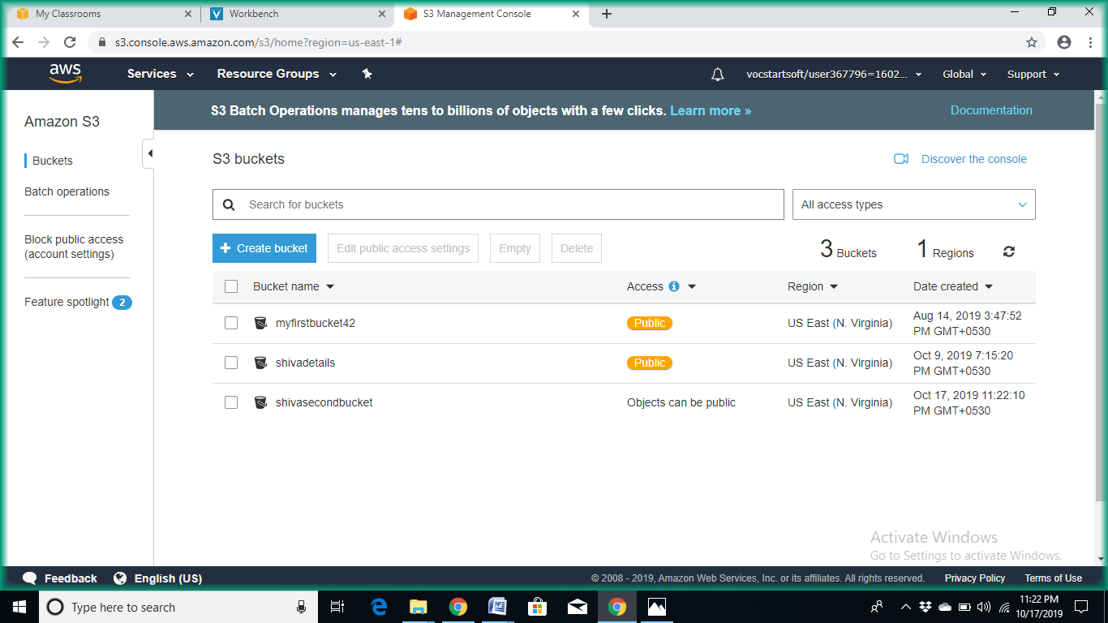

* Now click on the bucket you created

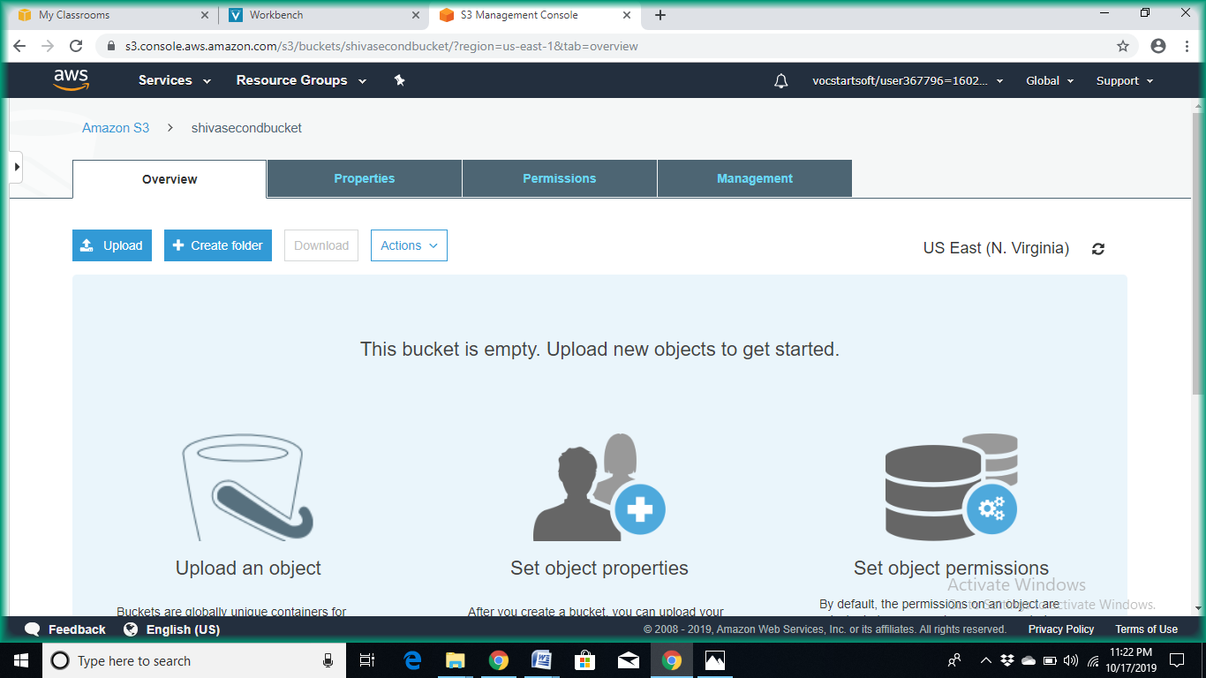

* Then click on **Permissions**

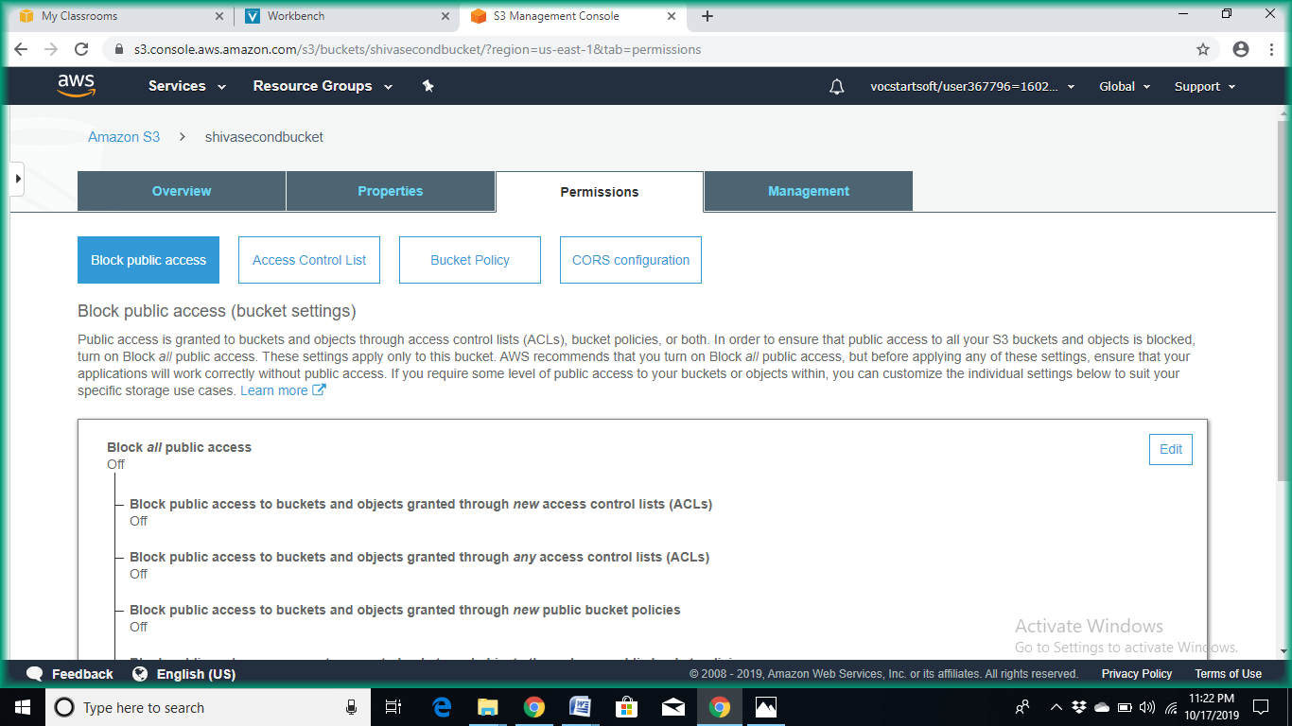

* Then click on “**Bucket Policy”**

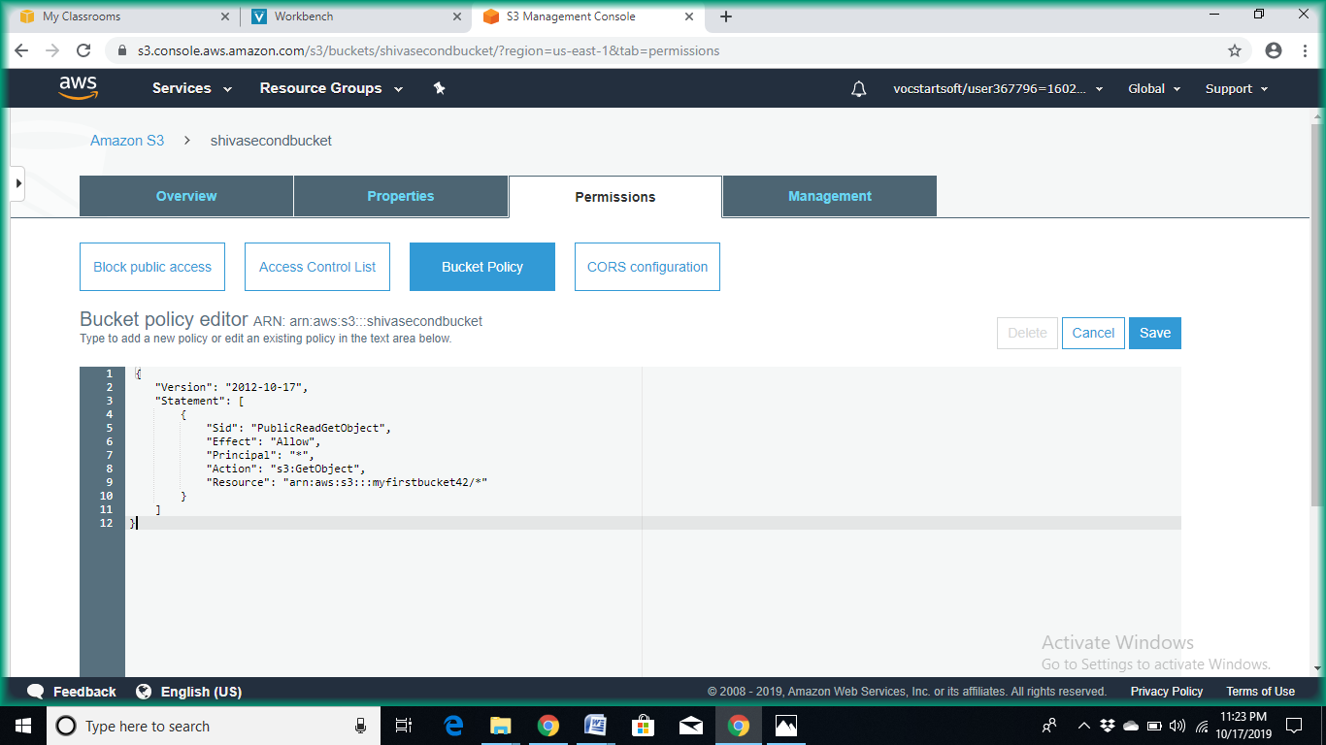

The bucket policy :

{

"Version": "2012-10-17",

"Statement": [

{

"Sid": "PublicReadGetObject",

"Effect": "Allow",

"Principal": "*",

"Action": "s3:GetObject",

"Resource": "arn:aws:s3:::<bucket-name>/*"

}

]

}

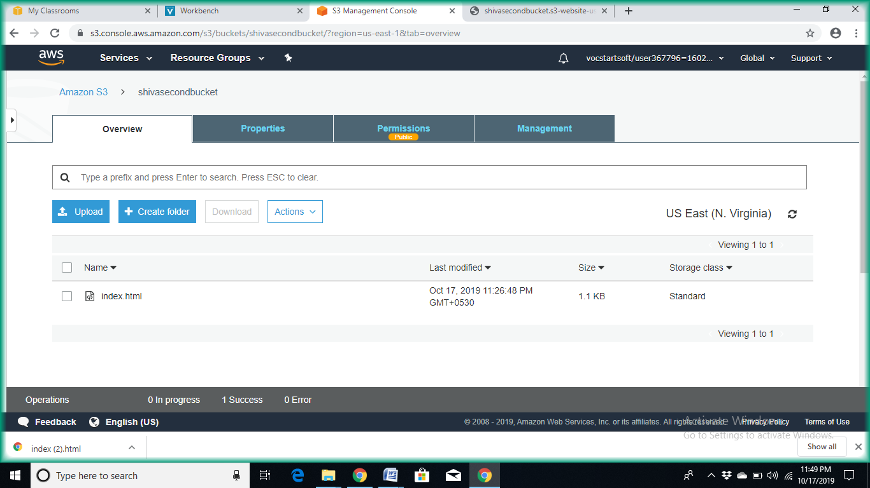

* Then click on “**Properties”**

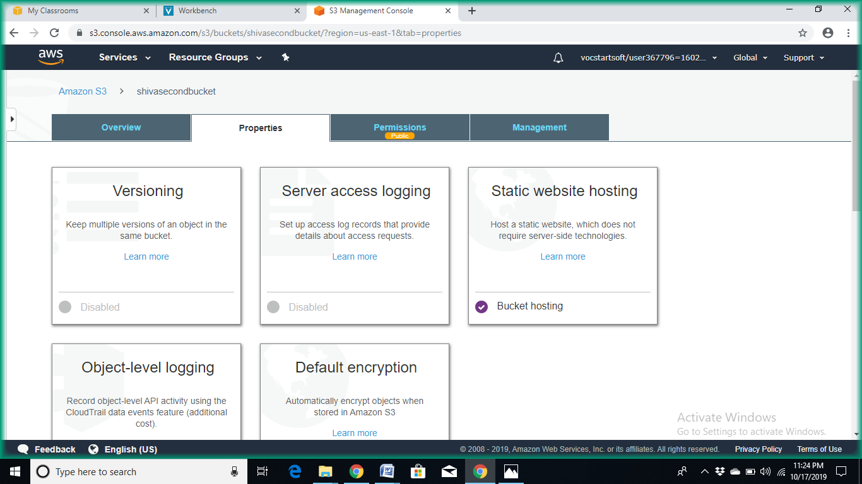

* Then click on “**Static website hosting”**

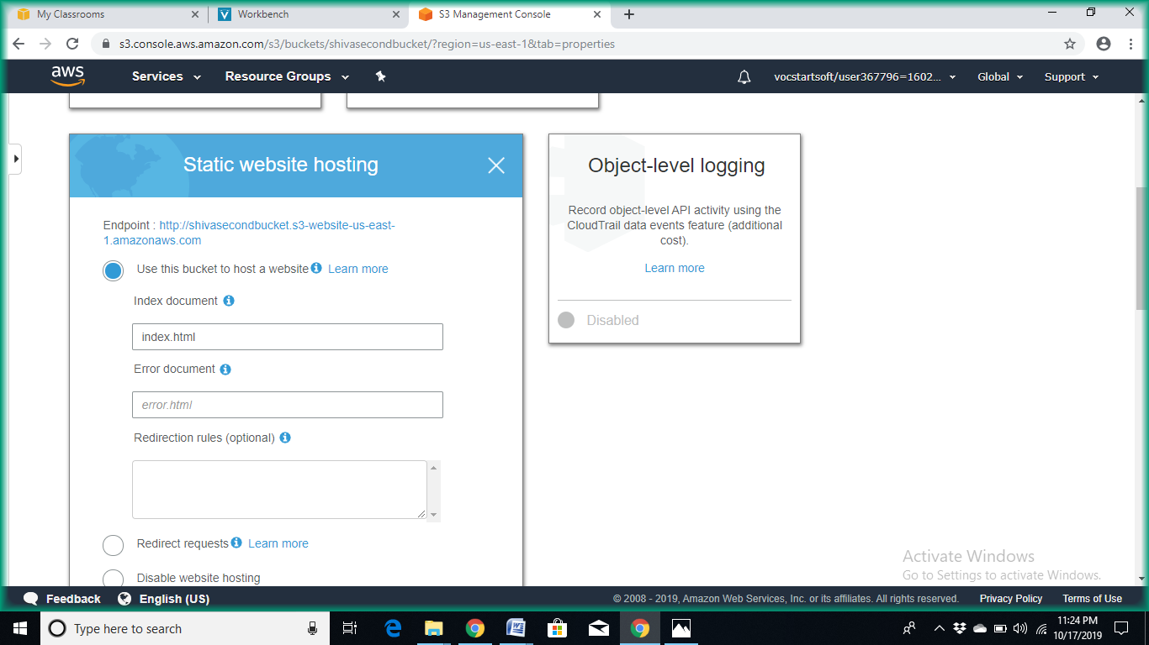

* Use the url to access the contents of the bucket

<http://shivasecondbucket.s3-website-us-east-1.amazonaws.com>



* Then click on “**upload**”

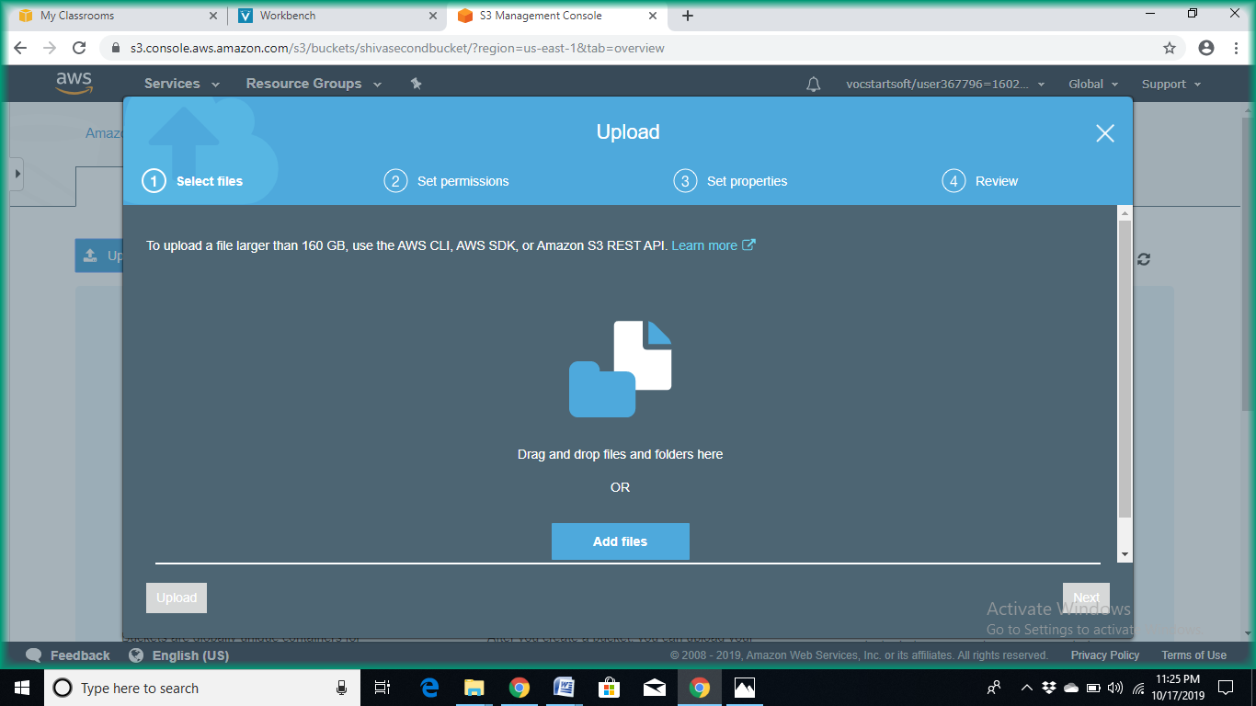

* Then click on “**Add files**”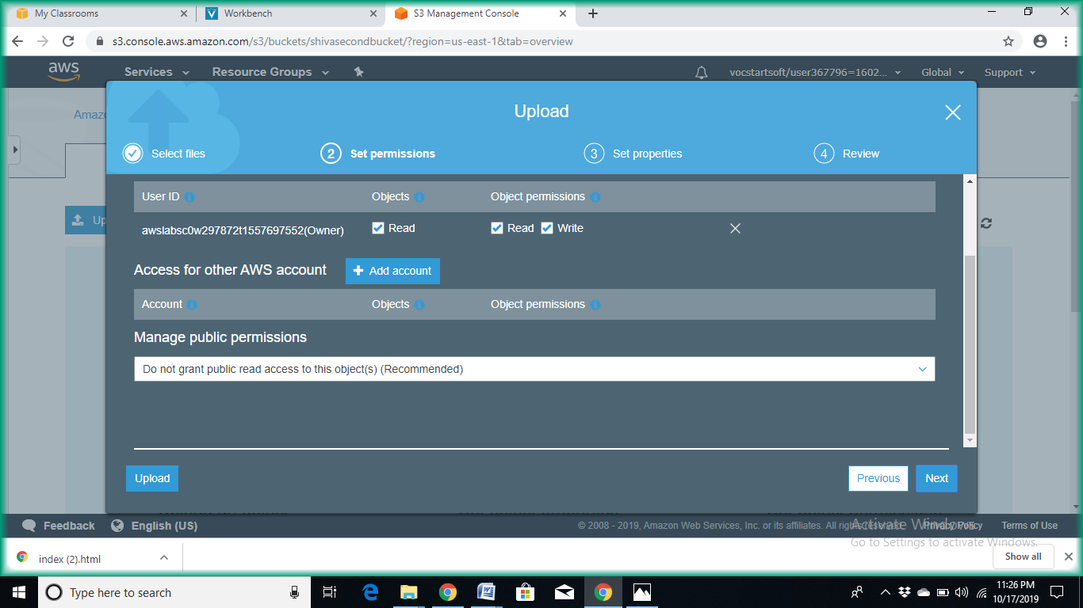



* Click on “**Next**”

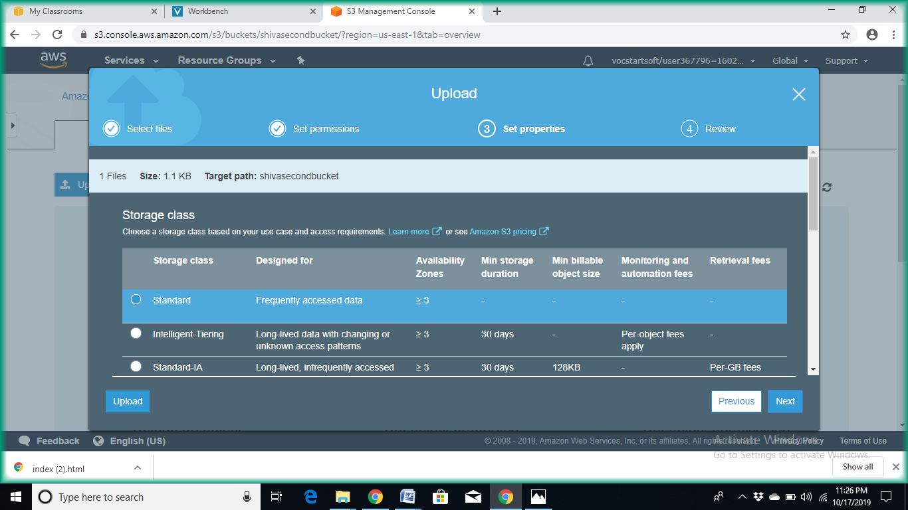

* Click on “**Next**”

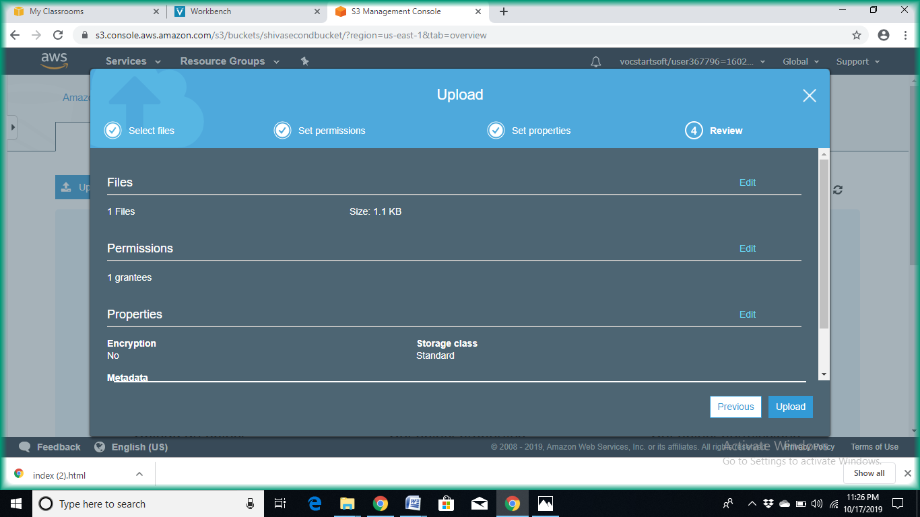

* Click on “**Next**”

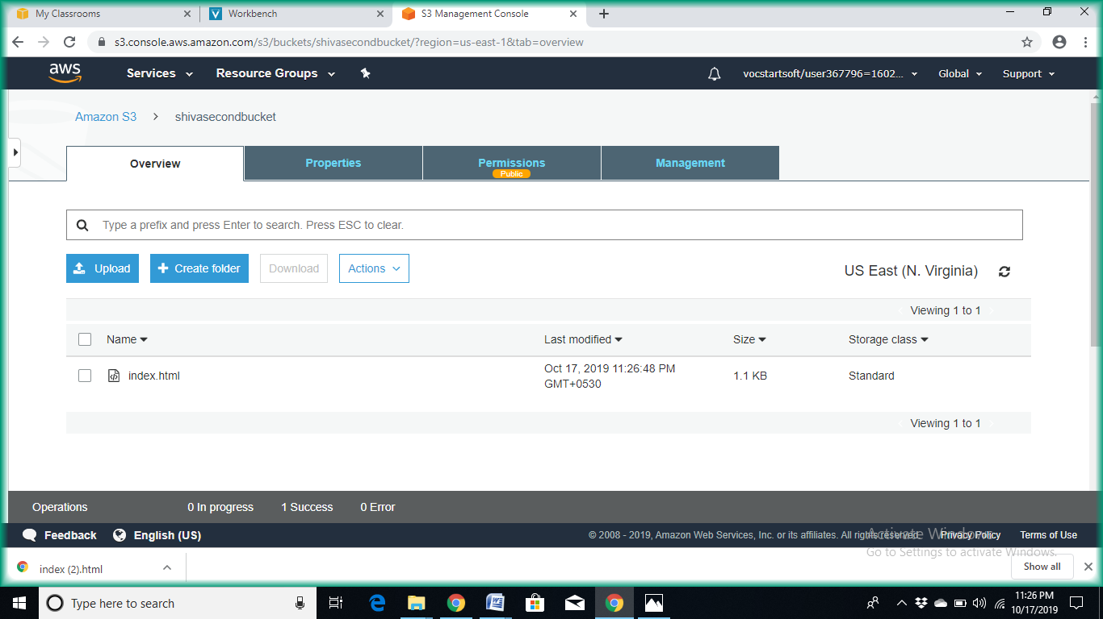

* Uploaded files appears here

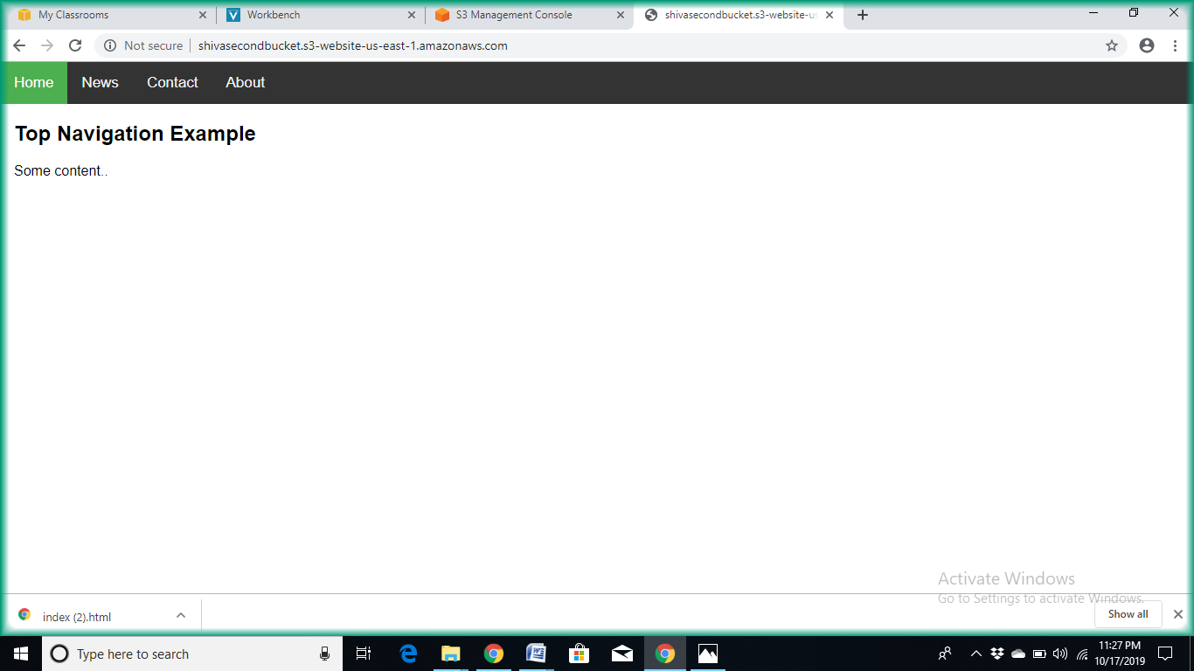

Now paste the url provided in the browser so that the website is running.

**Source Code:**

**//Index.html**

<html>

<h1>This is the sample page to upload on Amazon aws </h1/>

**Input / Output:**

This is the sample page to upload on Amazon aws.